**React Native Practical Guide**

This document will be a guide on setting up and running a sample application on react native. All the instructions of the practical is provided below for your reference.

Biggest skill of all – How to Google?

There going to be numerous places where you will be stuck on how to do things or with an error message. Googling and finding the solution on your own Is one of the biggest skills on development process.

<https://www.google.com/>

1. Environment Setup

In order to start with react native you need to verify both “git” and “node” installed in your machine. You can simply open your command prompt (Windows Search -> CMD) and type both git and node to see if it is installed. Else you need to download and install from their official websites. (During installation process, nothing needs to be changed just click “next” on all windows till “finish”)

Node – <https://nodejs.org/en/>

Git – <https://git-scm.com/>

Additional tools

Github/Sourcetree -   
<https://www.sourcetreeapp.com/>  
<https://desktop.github.com/>

Github - <https://github.com/>

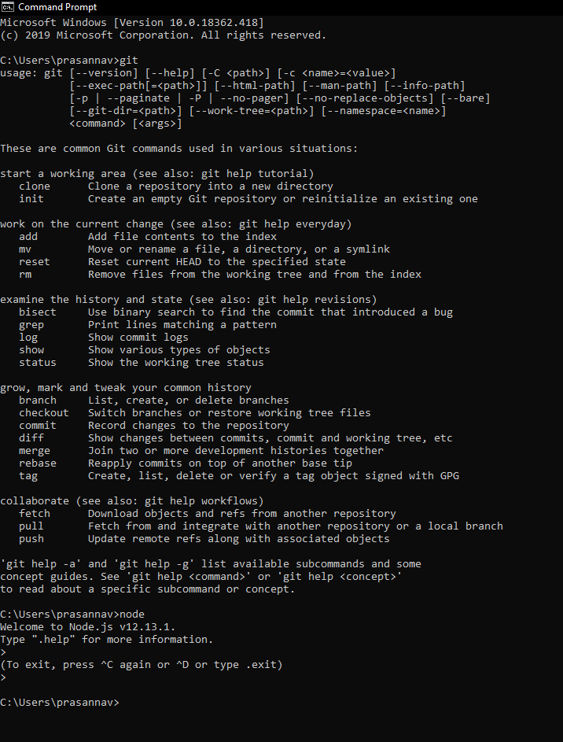

1. Installing Expo and First project

Next step is to install the expo client and set up using react native docs.

<https://facebook.github.io/react-native/docs/getting-started>

Open a new folder to create your project. Open up the command line from that folder (you can type cmd on the folder path)

Check if expo is already installed in your machine by typing “expo” in command line

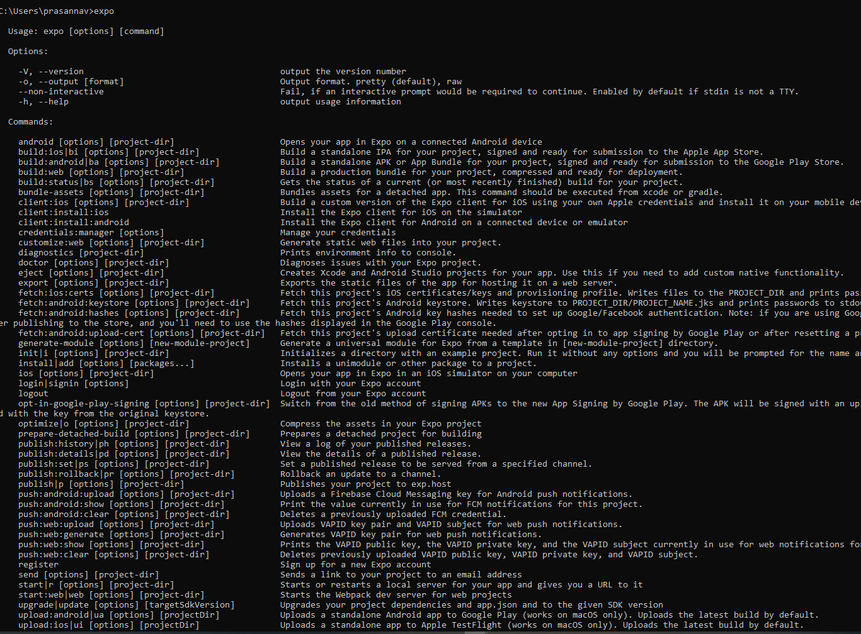

Install Expo Client globally (one time) if it is not there already using

npm install -g expo-cli

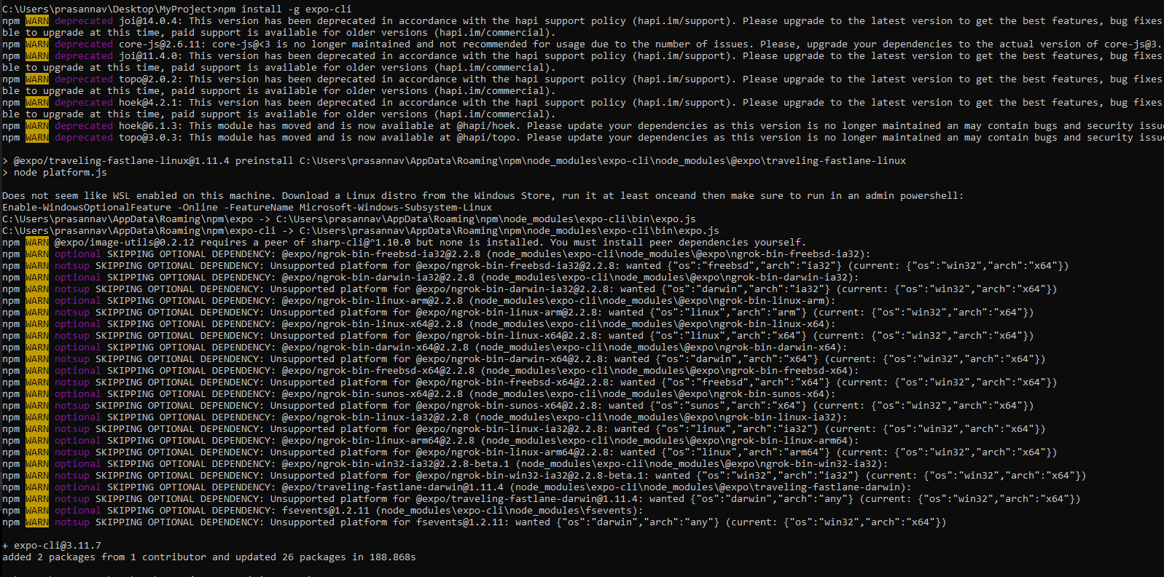

Create your first React Native Project using

expo init AwesomeProject

AwesomeProject can be renamed to your project name

Choose the blank template and install your project

Open your project folder in VScode to see the files and copy the contents of your App.js

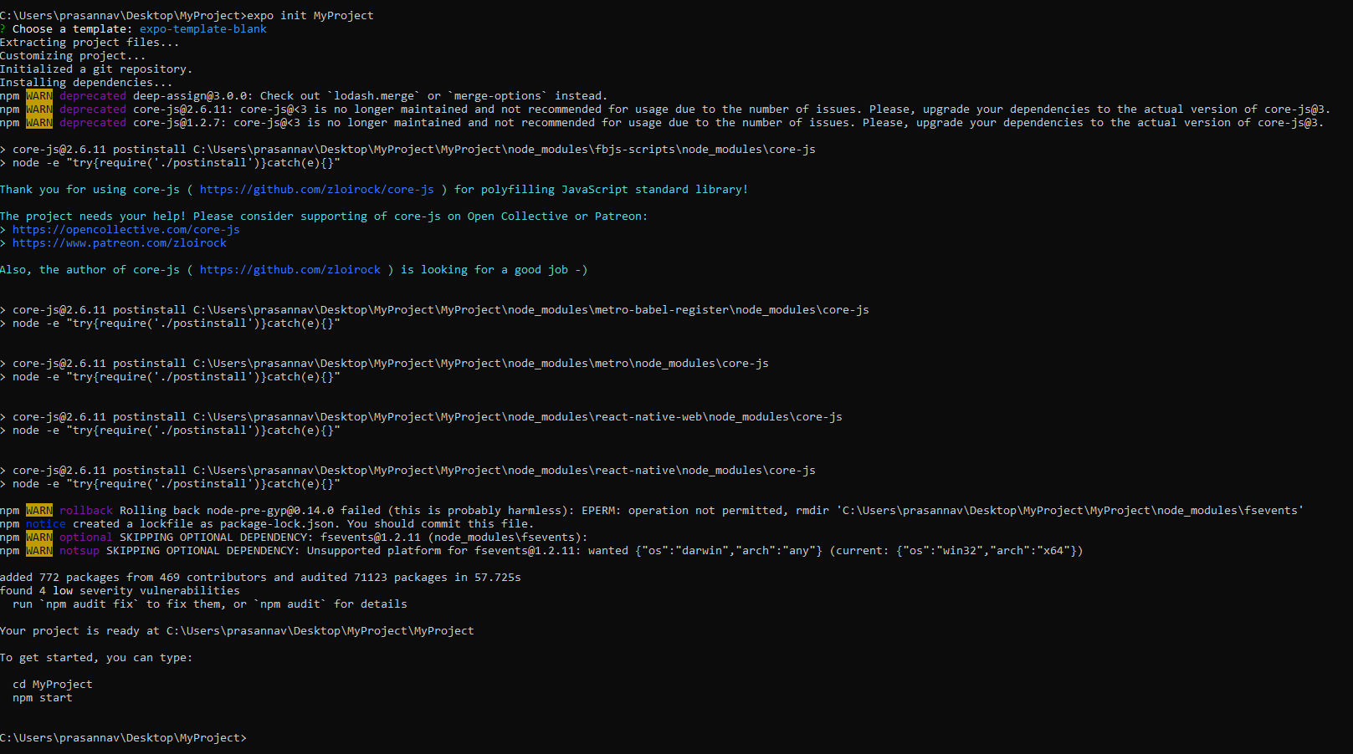

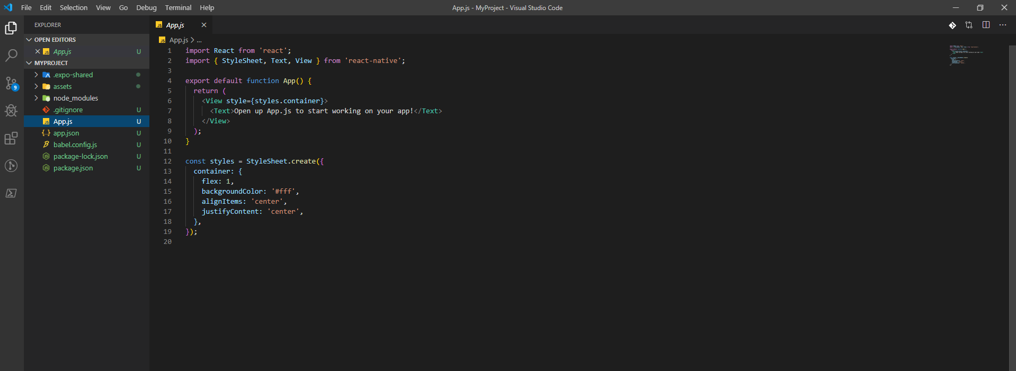

Log in to <https://snack.expo.io> and create a new Snack. This will give you an example project like below.

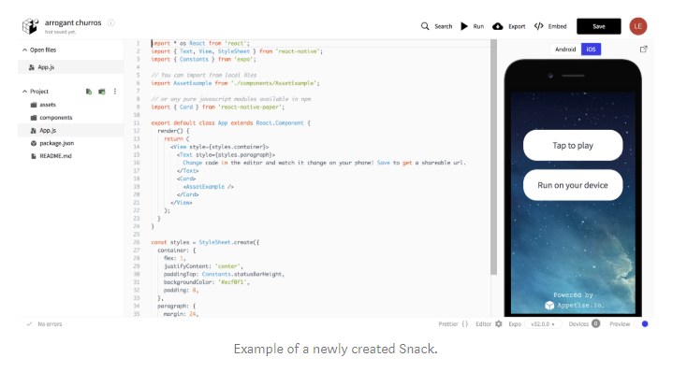

Copy the content of your App.js into the editor replacing the code and view the output on the screen to the right on the “Web” tab.

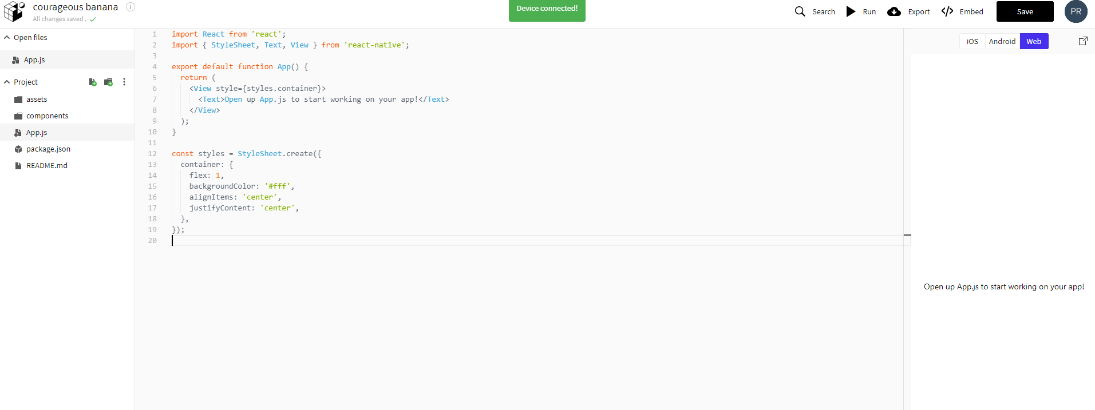

1. Create a button

Now that we have a basic app set up. We are going to add a button and navigate back and forth on an application.

To add a button simple, google “React Native Button” to learn about the UI primitive and pick a button from the sample.

Add your button under the <Text> in the same <View>

<https://facebook.github.io/react-native/docs/button>

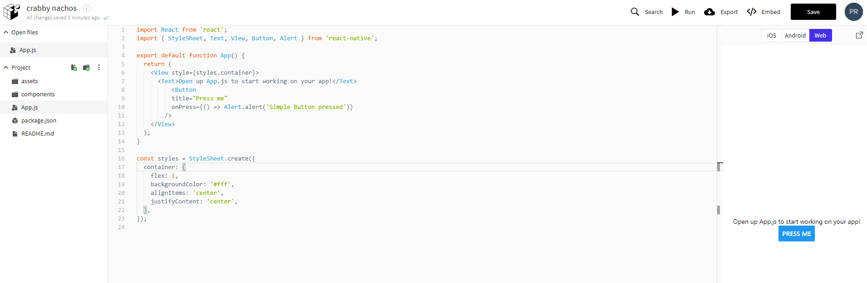

You will initially get few errors and make sure everything required are imported from the “react-native” library.

This is one example of learning a new UI primitive through the documentation.

1. Task – Create a Myself Page app

You need to create a page with your name as heading

You need to place your image

You need to enter few details below the image

Create a button which will alert your name.

Insert an image using the url - https://facebook.github.io/react-native/img/tiny_logo.png

1. View your app on your mobile device at run time

Click on “Run on your device” in the emulator on the right side. This will give you a modal asking for your Device Id. This is located in the Expo App under the Projects tab (which you should have downloaded by now) on your Android / iPhone device.

If you filled in the Device Id and clicked Save, there should be a green message that your device is connected. You can find the project below “Recently in development” in the Projects tab.

Open the project on your phone, every change you make on your browser should be reflected on your device.

